DFD (Context level Diagram):

Administrator

Accept/
Reject
Details

0

Visa Dispensation System

Details about onsite
Passport/
EMP Details

Onsite data
Visa Processing
Feedback

Feedback

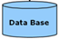

Report

DFD Diagram for Administrator:

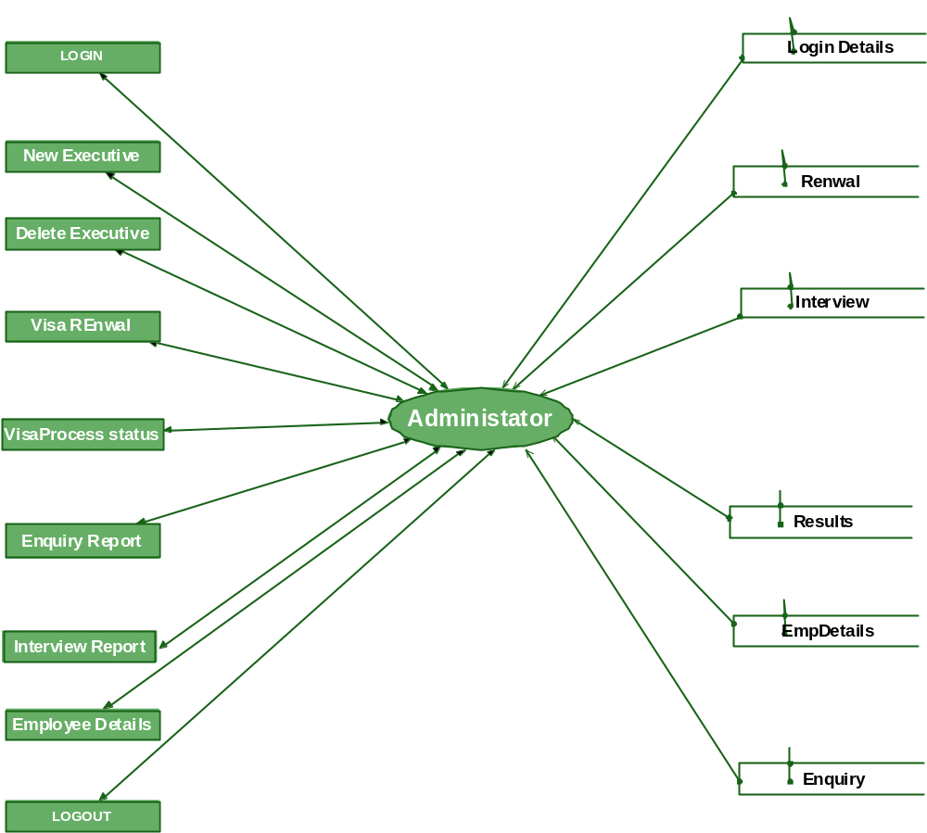

DFD Diagram for HR Manager:

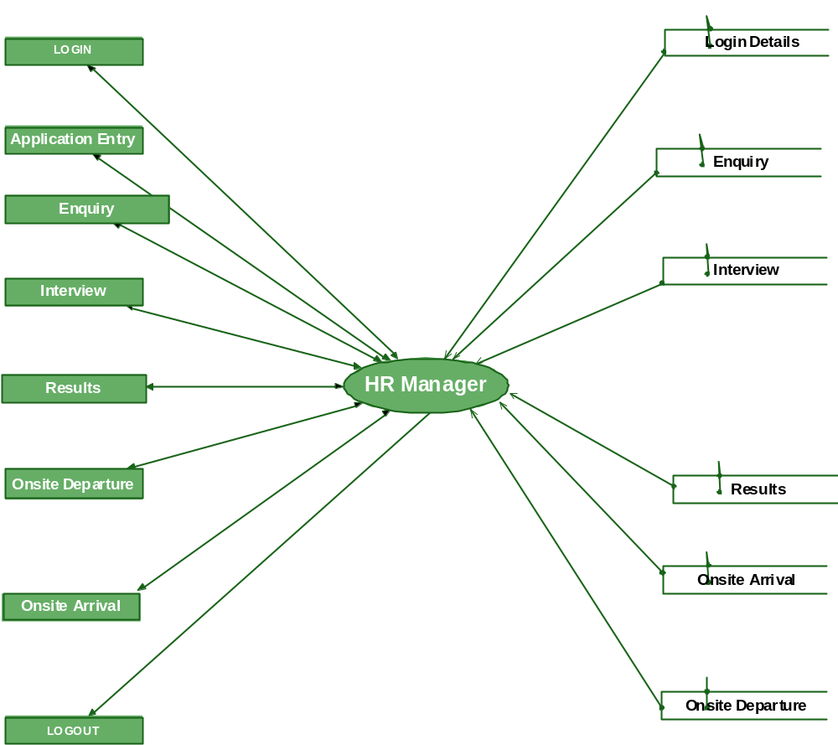

DFD Diagram for Employee:

